Measure LL
Citizens’ Bond Oversight Committee

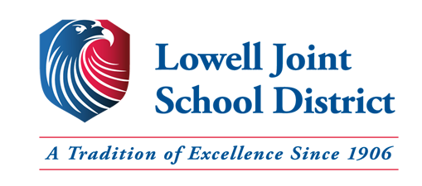

Annual Report
July 1, 2020 – June 30, 2021

January 10, 2022

Table of Contents
1.0 Overview.......................................................................................................3
2.0 Purpose..........................................................................................................3
3.0 Membership...................................................................................................3
4.0 Committee Activities….................................................................................4
5.0 District Support..............................................................................................4
6.0 Meeting Dates................................................................................................5
7.0 Project Updates..............................................................................................5
8.0 Audit Findings...............................................................................................8
9.0 Conclusion.....................................................................................................9
10.0 Additional Information..................................................................................9

- Overview
Lowell Joint School District (“District”) General Obligation Bond Measure LL (“Measure LL”) was approved by the voters on November 6, 2018. Approval of Measure LL authorized the District to issue up to an aggregate principal amount of $48,000,000 in General Obligation Bonds.
The Measure LL election was conducted under Proposition 39, being chaptered as the Strict Accountability in Local School Construction Bonds Act of 2000 and was approved and authorized subject to provisions of Section 1 of Article XIIIA of the California Constitution which established California Education Code Section 15278. California Education Code Section 15278 requires the establishment of an Independent Citizens’ Bond Oversight Committee (“Committee”) in order to satisfy the accountability requirements of Proposition 39.
The Board of Education of the Lowell Joint School District established the Independent Citizens’ Bond Oversight Committee on October 28, 2019. The Committee maintains the duties and rights set forth in the Bylaws. The Committee does not have legal capacity independent from the District. Moreover, the Committee is charged with responsibility for overseeing the expenditure of Measure LL projects and bond proceeds only.
- Purpose
The purposes of the Committee are set forth in Proposition 39, and the Committee Bylaws were developed and approved subject to the applicable provisions of Proposition 39. The Committee is subject to the Ralph M. Brown Public Meetings Act (“Brown Act”) of the State of California and meetings are conducted in accordance with the provisions thereof. The District provides necessary administrative support to the Committee consistent with the Committee’s purposes, as set forth in Proposition 39.
- Membership
The current Committee consists of seven members and includes representatives from the organizations required under Proposition 39:
- Parent or guardian of a child enrolled in the District (one representatives)
- Both parent or guardian of a child enrolled in the District and active in a parent-teacher organization, such as the Parent Teacher Association or a school site council (one representatives)
- Active in a business organization representing the business community located in the District (one representative)
- Active in a senior citizen’s organization (one representative)
- Active in a bona-fide taxpayers association (one representative)
- Members of the community at-large (two representatives).
The following table lists the members, group representing, and current terms.
Member | Representative Group | Current Term
Jan Averil | Tax Payer Organization | Dec. 2019 – Dec. 2021
Stuart Gothold | Active Senior Citizens Group | Dec. 2020 – Dec. 2021
Taffi Graham | At-Large Community | Dec. 2019 – Dec. 2021
Kim Johnson | Active PTA/Site Community Member | Dec. 2019 – Dec. 2021
Richard Jones | At-Large Community | Dec. 2020 – Dec. 2021
Casey Powers | Business Representative | Dec. 2020 – Dec. 2021
Martin Tourville | Parent/Guardian Enrolled Student | Dec. 2019 – Dec. 2021

- Community Activities
In order to perform the duties as set forth within the Bylaws, the Committee engaged in the following authorized activities (where applicable):
- District staff presented financial reports and regular updates on past, current, and future projects
- Posted copies of the 2019-20 annual Lowell Joint School District Building Fund (Measure LL) Financial and Performance Audits (“Audits”) required by Prop 39 (Article XIIIA of the California Constitution)
- Inspected District facilities and grounds for which bond proceeds have been or will be expended
- Reviewed efforts by the District to maximize bond proceeds by implementing various cost saving measures

- District Support
The District provided the Committee with the following technical and administrative assistance:
- Prepared and posted public notices, as required by the Brown Act. Ensured that all notices to the public were provided in the same manner as notices regarding meetings of the District Board
- Provided meeting rooms with audio/visual equipment
- Prepared and distributed copies of meeting materials, such as agendas and reports
- Retained all Committee records and provided public access to the District website
- Attended Committee proceedings and reported on the status of projects and expenditures of Bond proceeds. The following District staff provided administrative support:
  - David Bennett, Assistant Superintendent, Facilities & Operations
  - Andrea Reynolds, Assistant Superintendent, Administrative Services
  - Cathy Weissman, Bond Contracts & Accounting Compliance Manager
  - Denise Soto, Secretary Technician, Facilities & Operations

- Meeting Dates
During the 2020-21 year, the Committee met four (4) times. Meetings were held at the District Office as well as through Zoom during the pandemic.
2020/2021 Meetings
- September 8, 2020 (Location: Virtual through Zoom)
- December 8, 2020 (Location: Virtual through Zoom)
- March 9, 2021 (Location: Virtual through Zoom)
- June 8, 2021 (Location: Rancho Starbuck Intermediate School)

2021/2022 Meetings
- September 14, 2021 (Location: District Office)
- December 14, 2021 (Location: District Office)
- March 8, 2022 (Location: District Office)
- June 7, 2022 (Location: District Office)

- Project Updates
Listed below are six (6) of the seven (7) school sites within Measure LL. These projects will be completed with Measure LL funds.
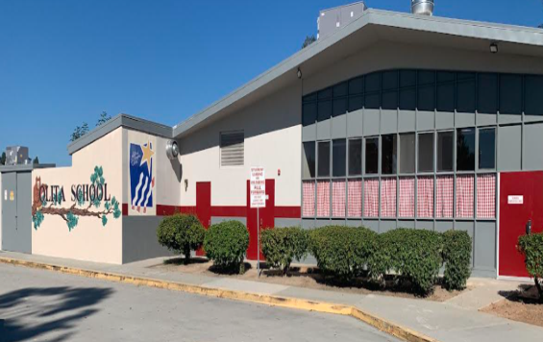
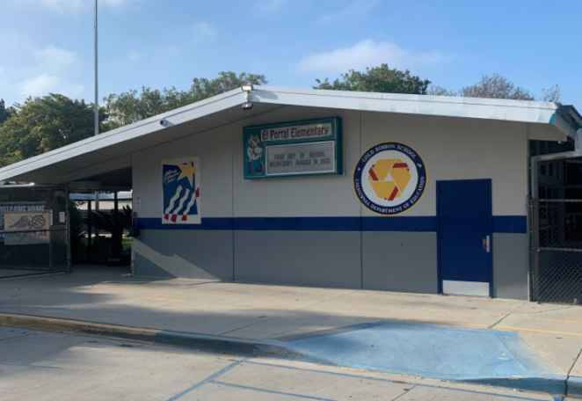
El Portal ES: Roofing and Fire Alarm Olita ES: Roofing, HVAC, and Fire Alarm
2020-21 Completed Projects

Projects in Progress
Macy ES: Roofing, HVAC, Fire Alarm, Sewer, Storm Drain
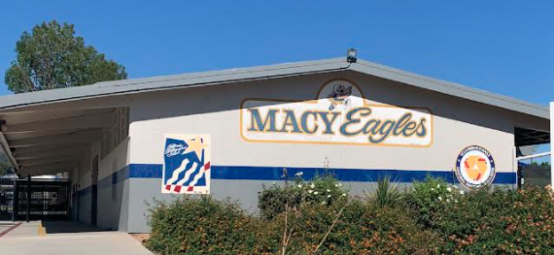
Projects in Progress
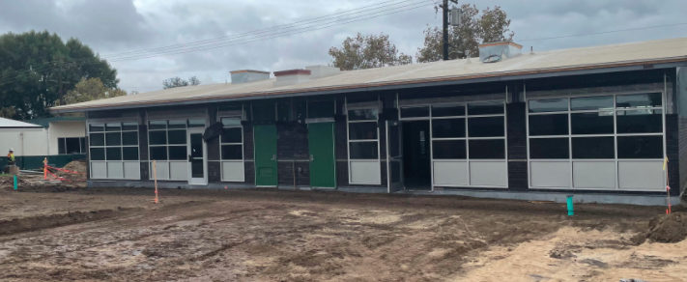
Jordan ES: Roofing, HVAC, Fire Alarm, Sewer, Portable to Permanent
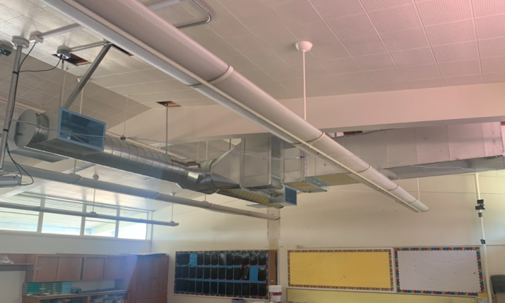
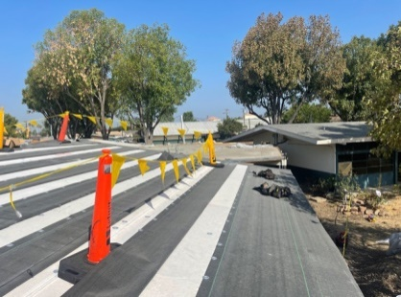
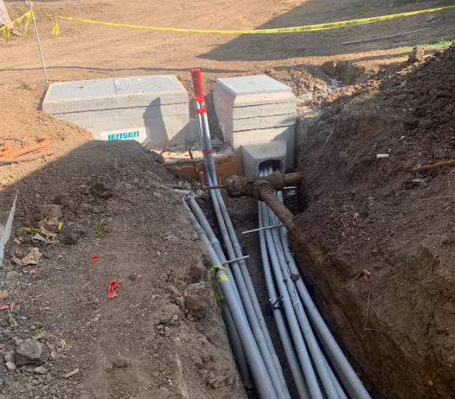
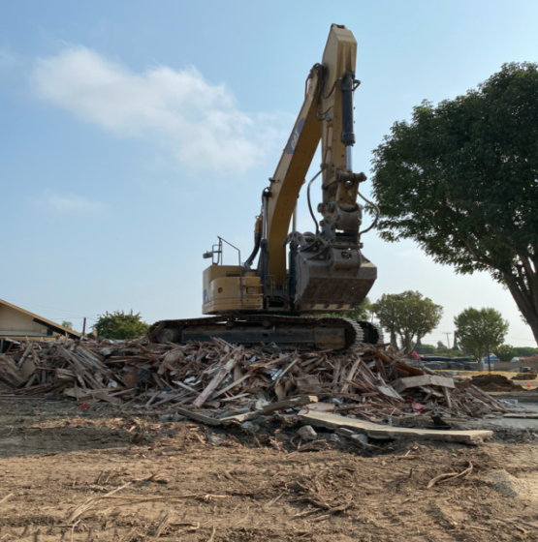

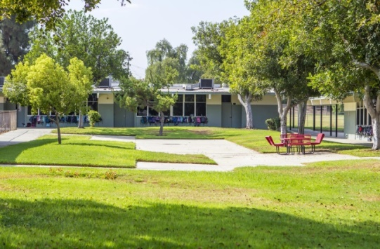
Meadow Green ES: Roofing, HVAC, Fire Alarm, Sewer
Upcoming Projects

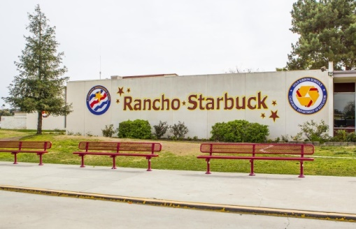
Rancho Starbuck IS: Roofing, HVAC, Fire Alarm, Sewer

- Audit Findings
The 2019-20 annual Lowell Joint School District Building Fund (Measure LL) Financial and Performance Audits had no findings.
- Conclusion
Based upon the listed activities, the Committee advises the public that the District is in compliance with Article XIIIA, Section 1(b)(3) of the California Constitution: Bond proceeds have been expended on projects set forth in the ballot measure. No bond proceeds have been used for teacher or administrative salaries or other school operating expenditures; and audits have been performed as prescribed bylaw.
- Additional Information
Meeting minutes, audits, and various other documents are available on the District website: https://www.ljsd.org/Departments/Citizens-Bond-Oversight-Committee/CBOC-Board-Agendas-and-Minutes/index.html.

